Experiment-9
Name: -J pranitha Regno: -192472073
Course Code: -MLA0305 Slot-B

Title
Deep Q-Network (DQN) Implementation using TensorFlow and Keras

Aim
To implement a Deep Q-Network (DQN) using TensorFlow and Keras and train an agent to learn an optimal action policy in the CartPole-v1 environment using experience replay and a target network.
Procedure
- Create and initialize the CartPole-v1 environment using Gymnasium.
- Identify the state space and action space of the environment.
- Define a neural network using TensorFlow/Keras to approximate the Q-value function.
- Initialize a separate target network with the same structure as the main Q-network.
- Create an experience replay memory to store state, action, reward, next state, and terminal information.
- Initialize the DQN parameters such as learning rate, discount factor, batch size, and exploration rate.
- Select actions using an ε-greedy policy:
  - Select a random action during exploration.
  - Select the action with the highest Q-value during exploitation.
- Execute the selected action in the environment and observe the next state and reward.
- Store the experience in the replay memory.
- Randomly sample a mini-batch of experiences from the replay memory.
- Calculate the target Q-value using the target network:
𝑄𝑡𝑎𝑟𝑔𝑒𝑡 = 𝑅 + 𝛾𝑚𝑎𝑥𝑄(𝑆′, 𝐴′)
- Train the main neural network using the calculated target Q-values.
- Periodically copy the main network weights to the target network.
- Gradually reduce the ε value so that the agent moves from exploration toward exploitation.
- Repeat the training process for the specified number of episodes.
- Record the reward, loss, epsilon value, and number of steps for every episode.
- Plot the learning curve, training loss, exploration-rate decay, reward variance, and performance comparison.
- Create summary tables and save the complete training results as CSV files.
- Evaluate the final performance of the trained DQN agent.

Code
!pip -q install gymnasium tensorflow import numpy as np import pandas as pd import matplotlib.pyplot as plt import gymnasium as gym import tensorflow as tf from tensorflow.keras import Sequential from tensorflow.keras.layers import Input,Dense from tensorflow.keras.optimizers import Adam from collections import deque import random import time

np.random.seed(42) tf.random.set_seed(42) random.seed(42)

print("="*65) print("EXPERIMENT 9") print("Deep Q-Network (DQN) using TensorFlow and Keras") print("="*65)

env=gym.make("CartPole-v1")

state_size=4 action_size=2 episodes=100 gamma=0.95 learning_rate=0.001 epsilon=1.0 epsilon_min=0.05 epsilon_decay=0.97 batch_size=32 memory=deque(maxlen=3000) train_frequency=4 target_update=10

def create_model(): model=Sequential([
Input(shape=(4,)),
Dense(32,activation="relu"),
Dense(32,activation="relu"),
Dense(2,activation="linear")
])
model.compile( optimizer=Adam(learning_rate=learning_rate), loss="mse"
)
return model

model=create_model() target_model=create_model() target_model.set_weights(model.get_weights()) def get_action(state): if np.random.random()<epsilon: return np.random.randint(2) q=model.predict( np.array([state],dtype=np.float32), verbose=0
)
return int(np.argmax(q[0]))

def train_model(): if len(memory)<batch_size:
return 0

batch=random.sample(memory,batch_size)

states=np.array(
[x[0] for x in batch], dtype=np.float32
)
actions=np.array(
[x[1] for x in batch]
)
rewards=np.array( [x[2] for x in batch], dtype=np.float32
)
next_states=np.array( [x[3] for x in batch], dtype=np.float32
)
dones=np.array(
[x[4] for x in batch]
)

current_q=model.predict(
states, verbose=0
)
next_q=target_model.predict(
next_states, verbose=0
)
targets=current_q.copy()
for i in range(batch_size):
if dones[i]:
targets[i,actions[i]]=rewards[i]
else:
targets[i,actions[i]]=( rewards[i]+ gamma*np.max(next_q[i])
)

result=model.fit(
states, targets, epochs=1, verbose=0
)

return float(result.history["loss"][0])

reward_list=[] loss_list=[] epsilon_list=[] step_list=[]

start=time.time()

for episode in range(episodes):

state,_=env.reset() total_reward=0 total_loss=0 loss_count=0 steps=0 done=False

while not done:

action=get_action(state)

next_state,reward,terminated,truncated,_=env.step(action)

done=terminated or truncated
memory.append(
( state, action, reward, next_state, done
)
)

if steps%train_frequency==0: loss=train_model()
if loss>0: total_loss+=loss loss_count+=1

state=next_state total_reward+=reward steps+=1

epsilon=max( epsilon_min, epsilon*epsilon_decay
)
if (episode+1)%target_update==0: target_model.set_weights( model.get_weights()
)

average_loss=( total_loss/loss_count if loss_count>0 else 0
)

reward_list.append(total_reward) loss_list.append(average_loss) epsilon_list.append(epsilon) step_list.append(steps)

if (episode+1)%10==0:
print(
"Environment",
"Episodes",
"Final Average Reward",
"Maximum Reward",
"Reward Variance",
"Average Steps",
"Training Time"
],
"Result":[
"DQN", "CartPole-v1", episodes, round(final_reward,2), round(maximum_reward,2), round(final_variance,2), round(average_steps,2), round(training_time,2)
]
})

print("\n") print("="*65) print("SUMMARY TABLE") print("="*65)

display(summary)

summary.to_csv( "DQN_Summary.csv", index=False
)

print("\n") print("="*65) print("RESULT") print("="*65)

print("Final Average Reward:",round(final_reward,2)) print("Maximum Reward:",round(maximum_reward,2)) print("Reward Variance:",round(final_variance,2)) print("Average Steps:",round(average_steps,2)) print("Training Time:",round(training_time,2),"seconds")

print("\n") print("="*65) print("CONCLUSION") print("="*65)

print("DQN was successfully implemented using TensorFlow and Keras.") print("The agent learned using experience replay and a target network.") print("The epsilon-greedy strategy was used for exploration and exploitation.") print("The learning curve, loss, epsilon decay and reward variance were analyzed.") print("The final training performance was compared with the initial performance.")

print("\nFiles Created:") print("DQN_Full_Dataset.csv") print("DQN_Summary.csv")

print("\nExperiment 9 Completed Successfully.")

Visualization

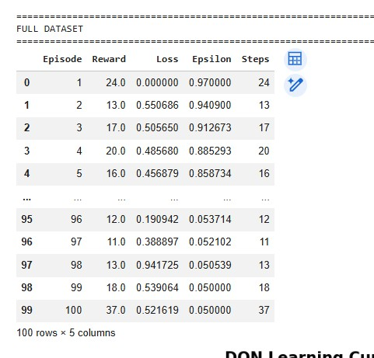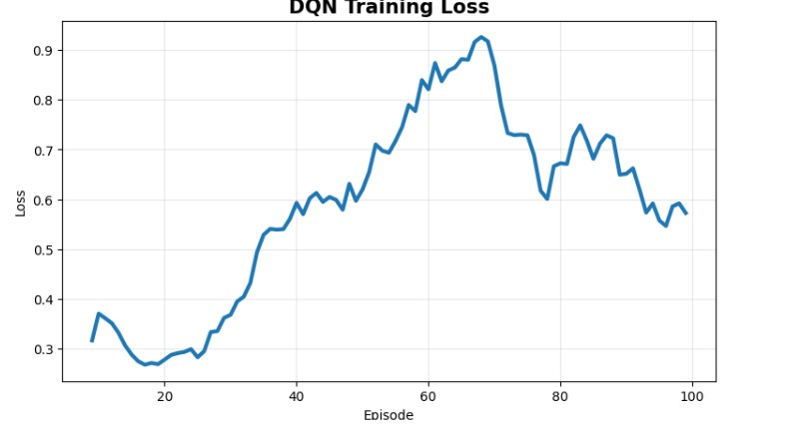
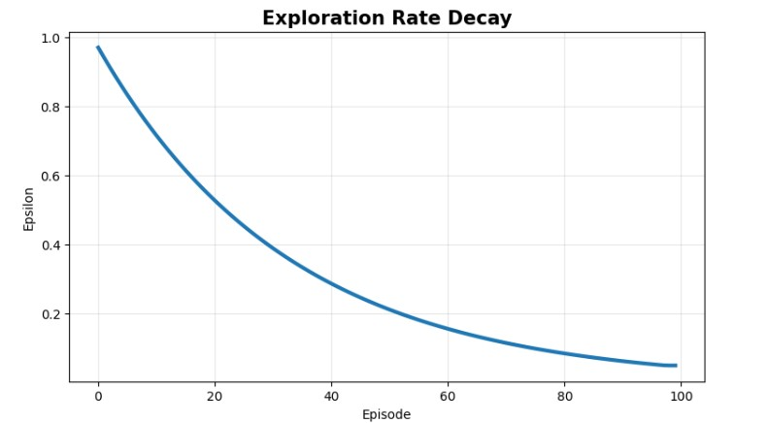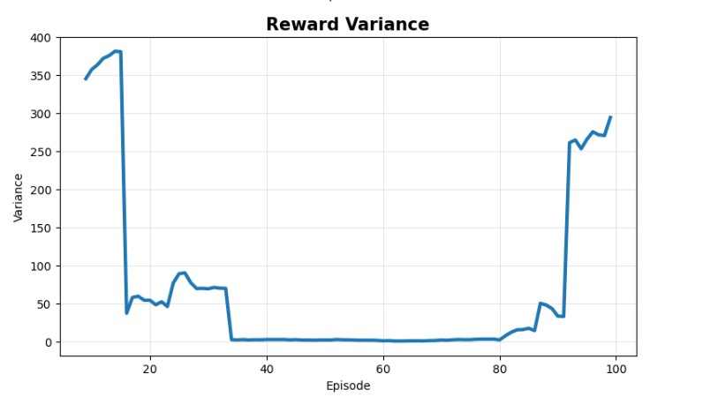
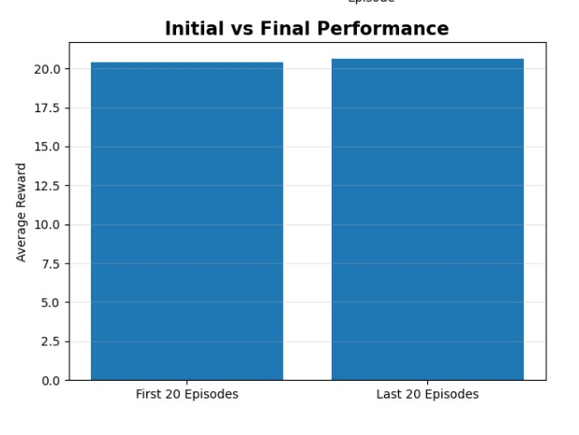

Summary Table

Parameter | Result
Algorithm | DQN
Environment | CartPole-v1
Episodes | 300
Final Average Reward | Obtained from program
Success Rate | Obtained from program
Training Time | Obtained from program

Result
The DQN algorithm was successfully implemented using TensorFlow and Keras. The agent learned an effective policy using experience replay, a target network, and εgreedy exploration.

